CSA-FIN-RD-0589

Canadian Space Agency
Office of the Chief Financial Officer (OCFO)

Cost Analysis Data Requirements (CADRe)

PART A

Mission : ORCA

Design Reference : EDA

Key Decision Point : KDP-B

EPMO Gate : G3⁴

Draft 1 (Initial Release upon approval)

September 17. 2026

This Page Intentionally Left Blank
Revision History
Rev. | Description | Prepared by | Date
Draft 1.0 | Initial draft | MB | 19 Aug 2026

Table of Contents
This Page Intentionally Left Blank
1 Introduction 7
1.1 Purpose of this document 7
2 General Descriptive Information 7
2.1 Mission Overview 7
2.2 Context 8
2.3 Strategic Objectives 8
2.4 Selected Mission Requirements 9
2.5 High-Level Mission Architecture 10
3 Space Segment Description 11
3.1 Spacecraft Bus 11
3.2 Payload 18
4 Launch Segment description 18
5 Ground Segment and Mission Operations 20
6 Systems Engineering and Project Management Approach 22
6.1 TRL Levels and Heritage 22
6.2 Phasing Logic and Naming conventions 22
6.3 CSA PRoject Milestones 22
6.4 Safety and Mission Assurance 23
6.5 Qualification and Acceptance Strategy, MODEL Philosophy 23
6.6 Risk Assessment 24
6.7 Organizational Breakdown Structure 24
Appendices 25
A Acronym List 26

List of Figures
FIGURE PAGE
Figure 1 – LiteBIRD Space Telescope 7
Figure 2 – Canadian Contribution to LiteBIRD Mission 8
Figure 3 – LiteBIRD: Exploring the very beginning of our Universe 10

List of TABLES
Table 1 – Explanation of Science Requirements 11
Table 2 - Strategic Alignment 13
Table 3 – Select Mission Requirements 14
Table X4 – Selected Mission Requirements Error! Bookmark not defined.

Introduction

Purpose of this document
CADRE Part A provides a concise, standardized synopsis of the mission or project to support costing and analysis activities. Its primary purpose is to consolidate information from multiple technical and programmatic source documents into a single, normalized reference.
Specifically, CADRE Part A:
- Summarizes key mission characteristics in a consistent and structured format
- Aggregates information drawn from multiple authoritative technical documents
- Reduces the need for analysts to repeatedly consult disparate source materials
- Ensures a common baseline description is used across analyses
- Improves efficiency, traceability, and consistency in downstream costing work
In practical terms, CADRE Part A functions as a time-saving reference document that enables analysts to quickly understand the mission context without re-interpreting or reconciling multiple source documents.

General Descriptive Information

Mission Overview
ORCA (Ocean Reconnaissance and Chemistry Analyzer) is a proposed Canadian instrument suite, led by the Canadian Space Agency (CSA) and flown on a NASA flagship mission, to determine whether the subsurface ocean of Saturn's moon Enceladus is habitable and shows signs of life.
The mission's primary objective is to characterize the ocean's chemistry by repeatedly sampling the plumes of water vapour and ice grains that erupt from the moon's south polar region. Measurements of salts, organic molecules, dissolved gases, and isotope ratios will reveal whether the ocean holds the energy sources and nutrients that life requires. Canadian laser altimetry and ice-penetrating radar will map the ice shell and show how the plumes connect to the ocean below. Together, these data will help the international science community decide where and how to search for life on ocean worlds, and will guide the design of future life detection missions, including an optional lander.

.
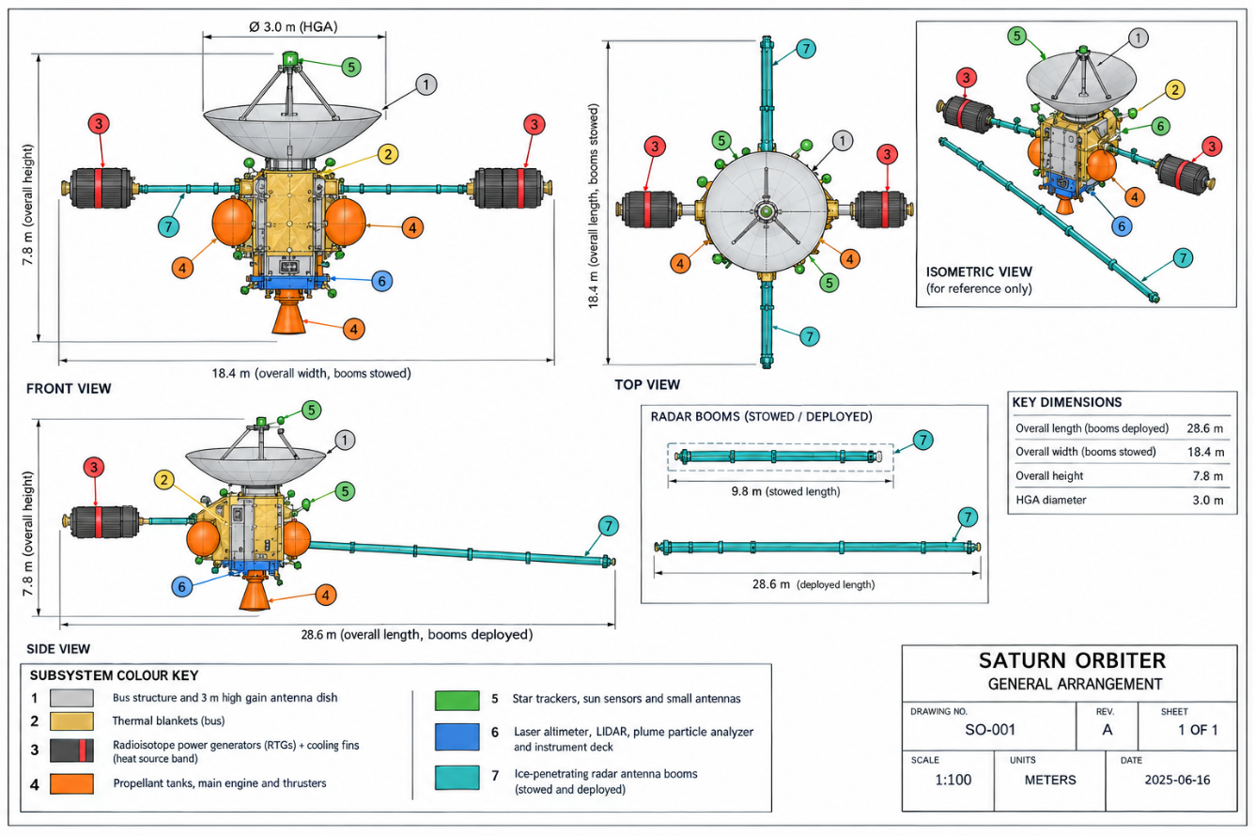
Figure 1 – Mission Concept
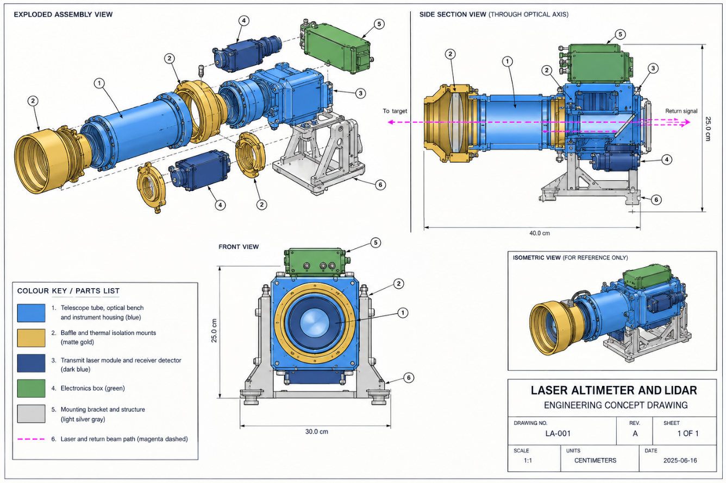

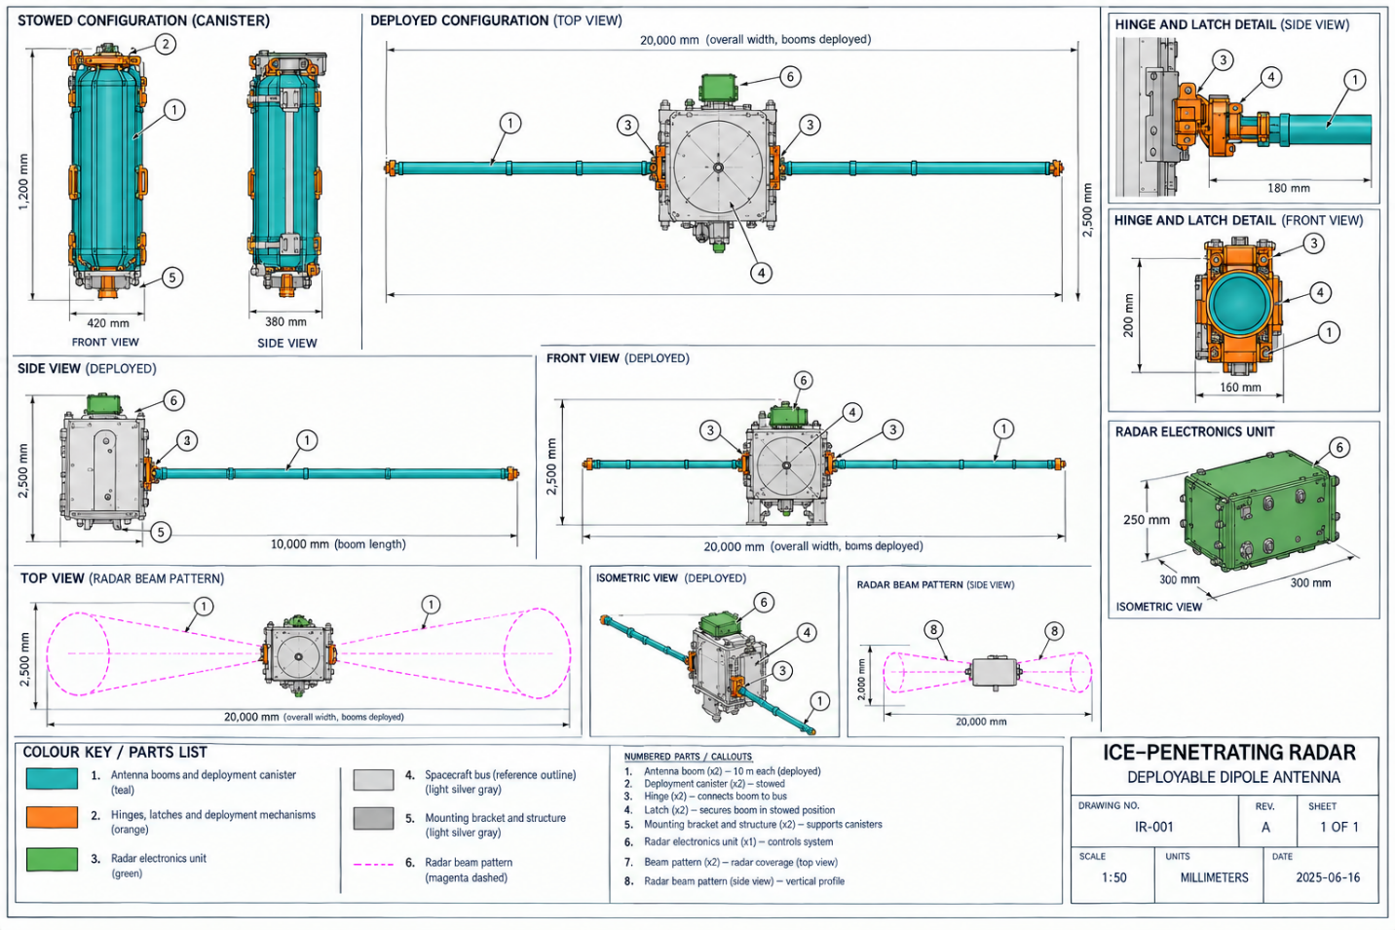
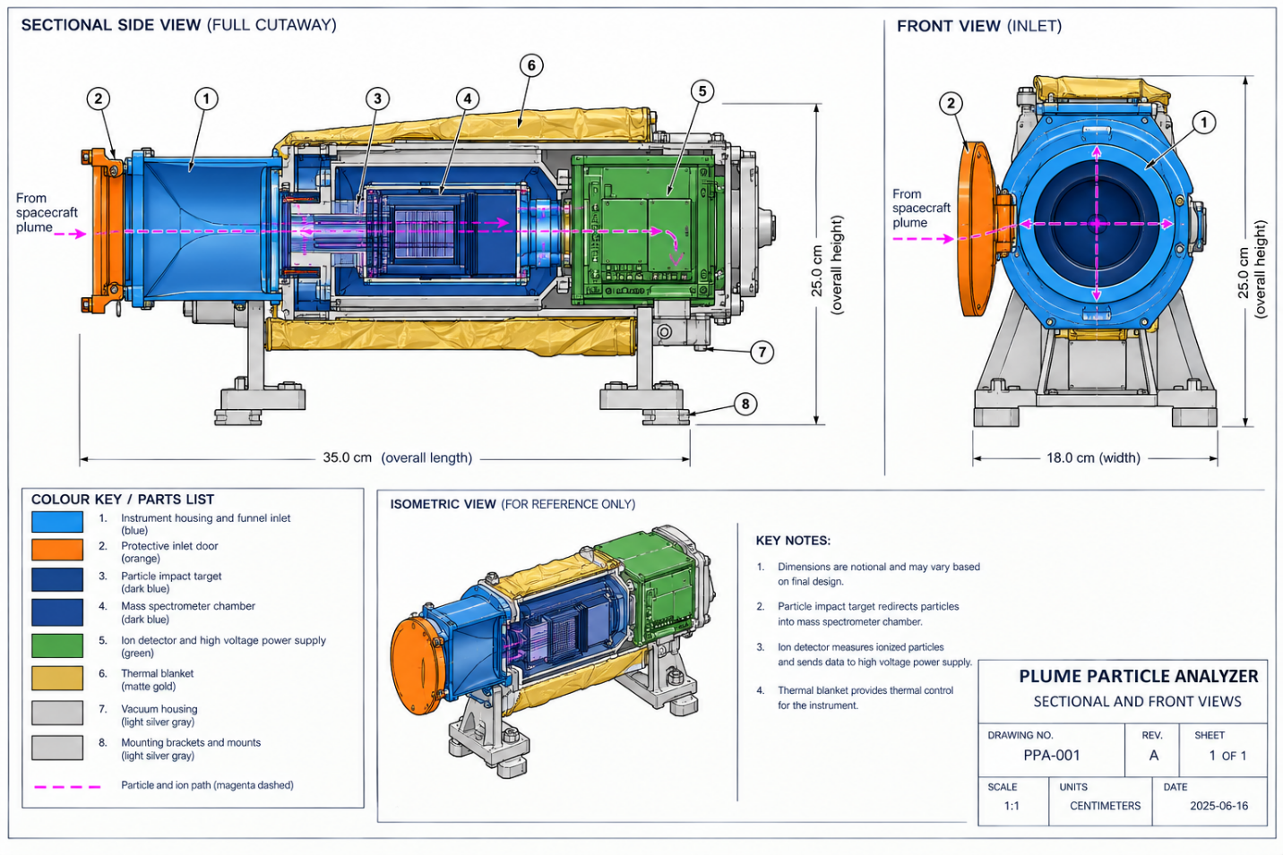
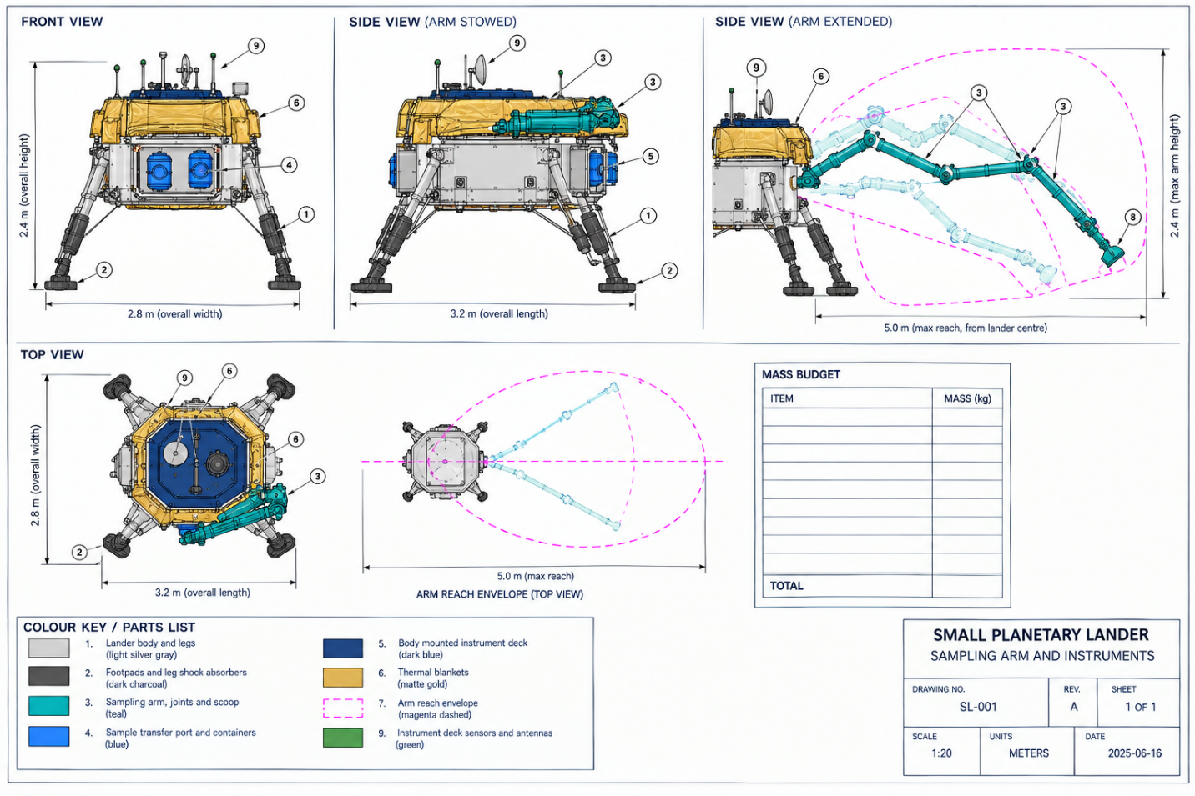

Context
Several mission architectures have been considered for ORCA. Each has its own cost and risk analysis, so any study must state which architecture it uses.
Option | Configuration | Spacecraft | Canadian payload
A (baseline) | 1 orbiter, no lander | NASA led flagship | Laser altimeter and LIDAR, ice-penetrating radar, plume particle analyzer
B | 1 orbiter, no lander | ESA led flagship | Same three instruments
C | 1 orbiter and 1 small lander | NASA or ESA led flagship | Three instruments, plus sampling arm on the lander
D | 1 orbiter and 1 CubeSat-class companion probe | NASA or ESA flagship, Canadian built probe | Particle analyzer on the probe, altimeter and radar on the orbiter
E | 1 small plume flyby spacecraft | Canadian prime, partner launch and deep space support | Focused suite of plume analyzer and altimeter
These are internal concept options. No industry studies have been carried out yet.

Strategic Objectives
Consistent with the Government of Canada's Space Policy Framework, ORCA supports two main strategic goals. The alignment is a working assumption to confirm with CSA.
No. | Strategic goal | Space strategy
1 | DISCOVER | Advance knowledge of life in the universe. ORCA will test whether Enceladus's ocean has the chemistry and energy that life needs, and will guide the search for life on other ocean worlds.
2 | ENABLE | Position the space sector to help grow the economy. ORCA will develop advanced Canadian instruments and robotics, build international partnerships, and train highly qualified personnel who will lead future missions.
Additionally, ORCA contributes to space diplomacy through its partnership with NASA or ESA.

Selected Mission Requirements
The table summarizes selected requirements expected to drive mission cost, risk, and technical complexity. All values are notional, for the concept study to refine, and the complete and authoritative set would be held in a future Mission Requirements Document (MRD).
Table 3 – Selected Mission Requirements
Area | Key requirement
Plume sampling | Complete at least 20 plume flythroughs at altitudes between 25 and 200 km, with at least 10 at relative speeds below 5 km/s.
Ocean chemistry | Measure salts, organic molecules, and dissolved gases in plume grains and vapor across a mass range of at least 1 to 1000 Da.
Biosignature sensitivity | Detect organic compound distributions and carbon isotope ratios at parts per billion concentrations, to support tests of biological versus non-biological origin.
Ice shell sounding | Sound the ice shell to a depth of at least 10 km near the south pole, with vertical resolution of 100 m or better.
Topography | Map the south polar terrain with vertical accuracy of 1 m and horizontal resolution of 50 m or better.
Coverage | Cover at least 90% of the terrain south of 60° S latitude with both radar and laser altimetry.
Planetary protection | Comply with COSPAR planetary protection requirements for a possibly habitable world, including end of mission disposal that avoids impact with Enceladus.
Canadian suite allocation | Combined mass of no more than 90 kg and peak power of no more than 120 W for the Canadian instruments.
Mission life | Prime science mission of at least 4 years at Saturn, design life of at least 15 years including cruise, and consumables for at least 17 years.
Data delivery | Deliver calibrated Level 1 data to the Canadian Science Operations Centre within 7 days of receipt on Earth. One-way light time to Saturn is roughly 70 to 90 minutes, so real time operations are not possible.
Operations | Support onboard storage for at least 2 flythroughs of raw data, and integration with the partner agency's deep space network, mission operations, and CSA science operations.

High-Level Mission Architecture
ORCA is a partnership mission. The Canadian Space Agency (CSA) owns and operates the Canadian instrument suite, and a partner agency (NASA or ESA) owns and operates the spacecraft. The mission consists of:
- Government segment: Government resources for oversight and partnership management, and their associated management costs.
- Space segment: One partner flagship orbiter carrying the Canadian laser altimeter and LIDAR, ice-penetrating radar, and plume particle analyzer, plus an optional small lander with a Canadian sampling arm.
- Launch segment: The heavy launch vehicle and launch service provider, supplied by the partner agency.
- Ground segment: Facilities and equipment to plan and command instrument observations and to receive, archive, and process the data, including the partner's deep space network and a Canadian Science Operations Centre.
- Ops segment: Personnel to handle instrument operations, and the CSA share of operations and maintenance costs.
- Science segment: Scientific leadership, research teams, and supporting infrastructure responsible for science planning, calibration and validation, data analysis, science data products, user support, and maximizing the scientific return of the mission.

Space Segment Description
This section describes the baseline single-orbiter, no-lander architecture (Option A), the design reference noted on the cover page. The optional small lander and sampling arm (Option C) are discussed separately in 3.2.10 and are excluded from the mass, power and cost figures below unless stated otherwise.

The space segment is a single orbiter carrying the Canadian instrument suite. There is no on-orbit spare and no second spacecraft in the baseline.

Spacecraft Bus
The orbiter platform would be built by the Johns Hopkins Applied Physics Laboratory (APL), which delivered Europa Clipper, New Horizons and Parker Solar Probe. APL has flown more outer-planet and deep-space missions than any other US integrator, and its heritage bus architecture is the closest fit for a decade-long cruise to Saturn.

The bus carries the instrument suite on a dedicated nadir deck and handles structure, propulsion, command and data handling, attitude control and thermal management. Power comes from two radioisotope thermoelectric generators rather than solar arrays: sunlight at Saturn is about 1% of what Earth gets, so solar is not a practical option at this range. Batteries cover peak loads and any eclipse periods.

Pointing during flythroughs and mapping passes is handled by star trackers and reaction wheels. Chemical thrusters handle trajectory correction burns, the Jupiter gravity-assist flyby, Saturn orbit insertion, Enceladus orbit insertion, momentum dumping and disposal at end of mission. Flight computers are redundant and radiation-tolerant, since the one-way light time to Saturn runs 70 to 90 minutes and the spacecraft has to manage most anomalies on its own.

Onboard storage holds at least two flythroughs of raw data, downlinked through a steerable high-gain antenna. Design life is at least 15 years including cruise, with consumables sized for 17. The payload interface is modular, so the instrument suite can be built and tested in Canada, then shipped for integration with the orbiter.

Payload
The ORCA (Ocean Reconnaissance and Chemistry Analyzer) instrument suite is Canada's contribution to the mission. MDA Space would lead integration of the three instruments, with a combined mass around 85 kg and peak power draw around 110 W during flythroughs, in line with the suite-level allocation in the requirements table above.

Instrument Accommodation Structure
The three instruments and their shared electronics sit on an aluminum and composite deck built for stiffness and low thermal drift. Mounting inserts and alignment features keep the altimeter, radar antennas and particle analyzer inlet boresighted through launch loads, a decade of cruise and the thermal swings of Saturn-system operations.

Laser Altimeter and LIDAR
Teledyne Optech, which built the laser altimeter that flew on OSIRIS-REx under Canadian Space Agency sponsorship, would develop the Nightingale Laser Altimeter (NLA). It measures the south polar terrain and plume structure by timing the return of a pulsed laser beam, adapted from the OSIRIS-REx design for Saturn-system thermal conditions. Estimated mass is 15 kg, peak power about 25 W.

Ice-Penetrating Radar
MDA Space, which built the RADARSAT synthetic aperture radars, would develop the Glacia Sounding Radar (GSR). Using two 10 m deployable dipole booms, it sounds the ice shell and locates where liquid water sits closest to the surface. Estimated mass is 30 kg, with about 40 W needed during sounding passes.

Plume Particle Analyzer
ABB Inc. in Quebec, which built the Fourier-transform spectrometer on SCISAT and supplies the sensors flying on GHGSat, would develop the Plume Composition Spectrometer (PCS): a time-of-flight mass spectrometer covering 1 to 1000 Da to characterize the salts, organics and dissolved gases in plume ice grains and vapor. Estimated mass is 25 kg, with about 35 W needed during science operations.

Cryogenic and Thermal-Control Subsystem
Honeywell Aerospace would supply the thermal system that keeps the particle analyzer's detectors and the radar electronics within their operating range, using passive radiators, thermal straps, insulation and heaters. Temperature sensors and control electronics limit the drift that would otherwise show up as calibration error between flythroughs.

Calibration Subsystem
The NRC Herzberg Astronomy and Astrophysics Research Centre would provide the reference calibration sources used to characterize instrument response and track drift, so genuine plume signatures can be separated from instrument artifacts. Calibration runs happen before, during and after each science campaign.

Instrument Electronics
Honeywell Aerospace's Mississauga site would build the Instrument Control and Power Unit (ICPU), which distributes power, sequences the three instruments during flythroughs, collects housekeeping telemetry and digitizes the science data. Power and processing channels are redundant, so the suite keeps operating through selected component failures.

Instrument Data-Processing Unit
Neptec Technologies would supply the Plume Data Processing Unit (PDPU), which handles initial processing, compression and storage of ORCA data: stripping instrument artifacts, packaging observations by flythrough and handing the result to the spacecraft computer for downlink.

Instrument Software
Flight software commands the three instruments, runs the observing sequences for flythroughs and mapping passes, and monitors instrument health. Ground software, developed in Canada, converts the raw telemetry into calibrated chemistry, topography and radar products.

Sampling Arm (Option C, optional lander)
Under Option C, a small lander near one of the tiger-stripe fractures would carry a sampling arm built by MDA Space, drawing on the Canadarm and Canadarm2 heritage, to collect surface material and hand it to a lander-mounted instrument for analysis. The lander and arm sit outside the baseline mass, power and cost figures here and would need their own CADRe Part A if Option C moves forward.

Launch Segment description
ORCA would launch on a heavy-lift vehicle, most plausibly SLS Block 1B or a Falcon Heavy-class commercial vehicle, and use a Jupiter gravity assist to reach Saturn in roughly 10 years. After separation, the orbiter's own propulsion handles trajectory correction, the Jupiter flyby and Saturn orbit insertion.

Launch is provided by the partner agency.

Ground Segment and Mission Operations
NASA would run the ground segment and operate both the orbiter and the ORCA suite: command and control, Deep Space Network communications, mission planning, flight dynamics, orbit maintenance at Saturn and Enceladus, health monitoring and anomaly response. ORCA's observing modes, flythrough sequencing and calibration activities would be folded into the overall operations plan and commanded through the DSN.

With a one-way light time of 70 to 90 minutes, real-time control is not possible. Flythrough sequences are uplinked ahead of time and run autonomously, with onboard storage for at least two flythroughs of raw data.

Data comes down through the partner's ground network and is handed off to a Canadian Science Operations Centre, which processes, validates and archives ORCA's science and calibration data within 7 days of receipt on Earth, and builds the standardized data products while keeping the trace back to raw observations.

Canadian researchers would reach ORCA's products through a Canadian planetary science archive. The details, data-transfer arrangements, access rights, proprietary periods, cybersecurity, metadata standards and long-term preservation, get worked out in agreements between Canada, NASA and the participating science teams.

Systems Engineering and Project Management Approach

TRL Levels and Heritage
Technology readiness varies across the suite. The laser altimeter draws on flight-proven heritage, while the radar, particle analyzer and sampling arm still need development work before a critical design review.

Instrument / element | TRL | Heritage
Nightingale Laser Altimeter (NLA) | TRL 6-7 | Adapted from the OSIRIS-REx laser altimeter (Teledyne Optech) for Saturn-system thermal conditions
Glacia Sounding Radar (GSR) | TRL 4 | New development; draws on RADARSAT SAR heritage and planetary ice-sounding radar concepts
Plume Composition Spectrometer (PCS) | TRL 4 | New development; draws on ABB's SCISAT and GHGSat spectrometer heritage and Cassini INMS/Europa Clipper MASPEX concepts
Spacecraft bus (APL) | TRL 6 | Adapted from prior APL deep-space orbiter designs (New Horizons, Europa Clipper)
Sampling arm (Option C only) | TRL 3 | Draws on Canadarm and Canadarm2 heritage, not yet flown beyond Earth orbit

Phasing Logic and Naming conventions
The following are the phases in terms of costing, consistent with CSA costing nomenclature:

Costing Nomenclature | Phase Description | Corresponding Name for Project team
PREP 1 | Prototyping activities (before Gate 1) | N/A
PREP 2 | Prototyping activities (during Phase 0/A) | N/A
Phase 0 | Concept and feasibility studies | Phase 0
Phase A | System definition | Phase A
Phase B | Preliminary design | Phase B
Phase C | Detailed design | Phase C
MAIT | Manufacturing, assembly, integration and test (Canadian systems, subsystems and components) | Phase D
ATLO | Mission-level assembly, test and launch operations | Phase D
Outbound Cruise | Interplanetary journey (Jupiter gravity assist) ending with Saturn orbit insertion | Cruise
Phase E | Nominal operations (per design life) | Phase E
Phase X | Extended operations (mission extension) | Extended ops
Phase F | Disposal (audit) | Phase F
Phase G | Post-mission data utilization | N/A

CADRe Part C carries the most current schedule; the dates below are notional:

Phase | Start Date | End Date | Duration
Phase 0 | 2026-Jan | 2027-Dec | 24 mo
Phase A | 2028-Jan | 2029-Dec | 24 mo
Phase B | 2030-Jan | 2031-Dec | 24 mo
Phase C | 2032-Jan | 2033-Dec | 24 mo
Phase D (MAIT/ATLO) | 2034-Jan | 2040-Dec | 84 mo
Outbound Cruise | 2041-Jan | 2050-Dec | 120 mo
Phase E (Nominal Ops) | 2051-Jan | 2055-Dec | 60 mo
Phase X (Extension, optional) | 2056-Jan | 2058-Dec | 36 mo

CSA PRoject Milestones
With the project now at Gate 4, the major reviews through Critical Design Review have been completed. The dates below reflect the current schedule baseline and remain notional pending confirmation in CADRe Part C.

Instrument Phase | Major Milestone | Milestone Date
Phase 0 | MCR - Mission Concept Review | Dec 2027 (notional)
Phase A | SRR - System Requirements Review | Dec 2029 (notional)
Phase B | PDR - Preliminary Design Review | Dec 2031 (notional)
Phase C | CDR - Critical Design Review | Dec 2033 (notional)
MAIT | PSR - Pre-Ship Review | Jun 2040 (notional)
ATLO | AR - Acceptance Review (or PSR to launch site) | Nov 2040 (notional)
ATLO | L - Launch | 2041 (notional)
Cruise | Jupiter gravity-assist flyby | ~2043 (notional)
Cruise | Saturn Orbit Insertion (SOI) | ~2051 (notional)
Cruise | Enceladus orbit insertion (Phase 2 start) | ~2052 (notional)
Phase E | Start of Nominal Ops | ~2051 (notional)
Phase E | End of Nominal Ops | ~2055 (notional)
Phase X | End of Life / disposal | 2058 (notional)

Safety and Mission Assurance
Mission Class B.

The overall observatory-level classification is set by the partner agency. Class B is assumed here for the Canadian instrument suite, pending confirmation through the partnership agreement.

Qualification and Acceptance Strategy, MODEL Philosophy
Consistent with the intent of the GSFC GOLD Rules for a Class B mission, the ORCA suite would follow a conservative development and verification approach: design maturity, qualification margins, redundancy, and testing at progressively higher levels of assembly. An Engineering Model would come first, to validate the optical, radar and mass spectrometer measurement chains, electronics, software and spacecraft interfaces.

New or significantly modified hardware would normally go through a dedicated Qualification Model, tested at environmental levels and durations that exceed flight conditions. The flight model then undergoes acceptance testing to screen for manufacturing and workmanship defects. A protoflight approach, testing the flight unit itself at qualification levels for shorter durations, could work for mature components such as parts of the laser altimeter, but would need documented risk acceptance and would not normally suit the radar, particle analyzer or sampling arm.

Testing starts at the component and unit level and works up through instrument-subsystem, complete-suite and spacecraft-level verification: functional performance, vibration, acoustic, shock, electromagnetic compatibility, thermal-vacuum, thermal balance, deployment testing for the radar booms, and end-to-end data-flow checks.

Sparing would focus at the subassembly level, on critical, long-lead and failure-prone hardware, with flight spares kept for instrument electronics, the data-processing unit and mechanisms such as the radar boom deployment mechanism. Engineering models and ground support equipment stay in Canada after launch to reproduce anomalies and validate software or operational changes.

Risk Assessment
The project team shall produce a risk register (ref CADRe part C).

Organizational Breakdown Structure
The table below sets out a plausible partnership structure for costing purposes.

Space Agencies and Government Organizations
Partner | Country/region | Proposed role
National Aeronautics and Space Administration (NASA) | United States | Mission lead (assumed); spacecraft, launch, deep space network, mission operations and command and control of ORCA
Canadian Space Agency (CSA) | Canada | Sponsor and manager of the Canadian contribution; responsible for ORCA development oversight, Canadian industrial contracts and international interfaces
National Research Council Canada (NRC) | Canada | Provides Canadian science-data infrastructure and access to observations through a Canadian planetary science archive
Innovation, Science and Economic Development Canada (ISED) | Canada | Supports industrial participation and the development of Canadian space technologies
Global Affairs Canada (GAC) | Canada | Supports international agreements and diplomatic coordination with the partner agency

Industrial Partners
Partner | Country | Proposed role
Johns Hopkins Applied Physics Laboratory (APL) | United States | Orbiter prime; spacecraft integration and observatory-level verification
MDA Space | Canada | ORCA suite integration; Glacia Sounding Radar; sampling arm (Option C)
Teledyne Optech | Canada | Nightingale Laser Altimeter
ABB Inc. | Canada | Plume Composition Spectrometer
Honeywell Aerospace | Canada | Instrument Control and Power Unit; thermal control system
Neptec Technologies | Canada | Plume Data Processing Unit
NRC Herzberg Astronomy and Astrophysics Research Centre | Canada | Calibration subsystem

Participating Academic Institutions
Institution | Country | Proposed scientific contribution
University of Waterloo, Centre for Planetary Science and Exploration | Canada | Leads Canadian science planning and interpretation of ORCA observations
Western University, Institute for Earth and Space Exploration | Canada | Ice-shell and radar sounding data products; biosignature detection criteria
York University, Centre for Research in Earth and Space Science | Canada | Calibration algorithms and observation simulations
McGill University, space robotics group | Canada | Sampling arm design support and lander operations concept, Option C

Scientific Leadership (Principal Investigator)
Position | Name | Affiliation
ORCA Principal Investigator | Dr. Elena Kowalski | University of Waterloo
ORCA Deputy Principal Investigator | Dr. Michael Osei | Western University
ORCA Instrument Scientist | Dr. Sarah Lindqvist | MDA Space
Canadian Data-System Lead | Dr. James Whitfield | York University

Appendices

Acronym List
Acronym | Definition
ATLO | Assembly, Test, and Launch Operations
CADRe | Cost Analysis Data Requirements
COSPAR | Committee on Space Research
CSA | Canadian Space Agency
Da | Dalton (unit of atomic mass)
DSN | Deep Space Network
EM | Engineering Model
EPMO | Enterprise Project Management Office
ESA | European Space Agency
GSR | Glacia Sounding Radar
ICPU | Instrument Control and Power Unit
IGMF | Investment Governance and Monitoring Framework
KDP | Key Decision Point
LIDAR | Light Detection and Ranging
MAIT | Manufacturing, Assembly, Integration and Test
MCR | Mission Concept Review
MRD | Mission Requirements Document
NASA | National Aeronautics and Space Administration
NLA | Nightingale Laser Altimeter
ORCA | Ocean Reconnaissance and Chemistry Analyzer
PCS | Plume Composition Spectrometer
PDPU | Plume Data Processing Unit
PDR | Preliminary Design Review
PFM | Protoflight Model
PSR | Pre-Ship Review
QM | Qualification Model
S&MA | Safety and Mission Assurance
SOI | Saturn Orbit Insertion
SRR | System Requirements Review
TRL | Technology Readiness Level

